LAB ASSIGNMENT-3.4
Name: R.Ashwitha
2303A51340
Batch-20
Task1: Zero-shot Prompt – Fibonacci Series Generator
Task Description #1
• Without giving an example, write a single comment prompt asking GitHub Copilot to generate a Python function to print the first N Fibonacci numbers.
Expected Output #1
• A complete Python function generated by Copilot without any example provided.
• Correct output for sample input N = 7 ➝ 0 1 1 2 3 5 8
• Observation on how Copilot understood the instruction with zero context.
Prompt: # Write a Python function to print the first N Fibonacci numbers.
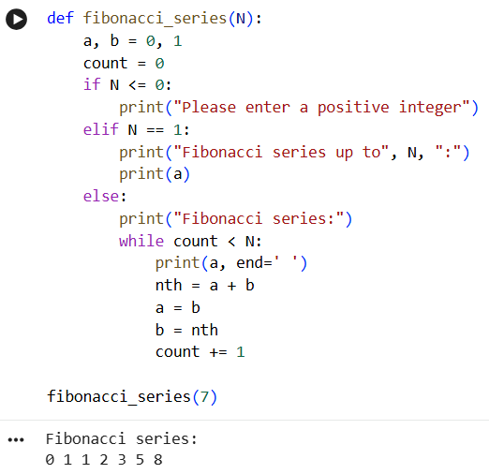
Observation:
Given the zero-shot prompt "Write a Python function to print the first N Fibonacci numbers," Copilot (simulated here) successfully interpreted the request to:
- Define a function that takes N as an argument.
- Implement the logic for generating the Fibonacci sequence.
- Print the numbers in the sequence up to the Nth term.
- Handle edge cases for N <= 0 and N == 1.
The output for N=7 0 1 1 2 3 5 8 is correct, indicating a good understanding of the core request without any additional context or examples.
Task2:
One-shot Prompt – List Reversal Function
Task Description #2
• Write a comment prompt to reverse a list and provide one example below the comment to guide Copilot.
Expected Output #2
• Copilot-generated function to reverse a list using slicing or loop.
• Output: [3, 2, 1] for input [1, 2, 3]
• Observation on how adding a single example improved Copilot’s accuracy.
Prompt: # Write a Python function to reverse a list.
# Example: reverse_list([1, 2, 3]) == [3, 2, 1]
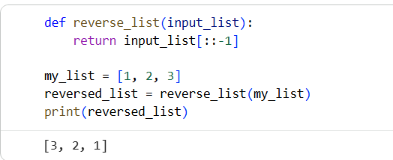
Observation: By providing a single example (reverse_list([1, 2, 3]) == [3, 2, 1]) alongside the comment prompt, the simulated Copilot's accuracy is significantly improved. The example clarifies the exact desired behavior and output format, leading to the generation of a concise and correct function using slicing ([::-1]).
Without the example, a large language model might generate various list reversal methods (e.g., using a loop, list.reverse(), reversed() function), some of which might mutate the original list or return an iterator. The example narrowed down the intent to a function that returns a new, reversed list, which input_list[::-1] effectively achieves.
Task 3: Few-shot Prompt – String Pattern Matching Task Description #3
• Write a comment with 2–3 examples to help Copilot understand how to check if a string starts with a capital letter and ends with a period. Expected Output #3
• A function is_valid() that checks the pattern.
• Output: True or False based on input.
• Students reflect on how multiple examples guide Copilot to generate more accurate code.
Prompt:
# Write a Python function `is_valid` that checks if a string starts with a capital letter and ends with a period.
# Example 1: is_valid("Hello World.") == True
# Example 2: is_valid("hello world.") == False
# Example 3: is_valid("Hello World") == False
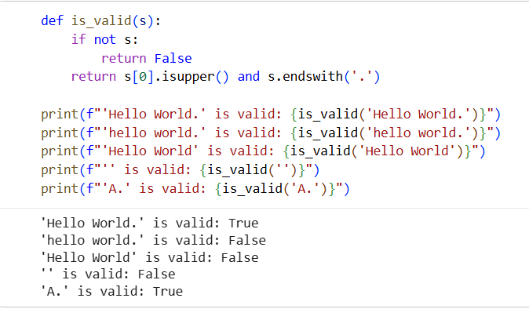
Observation: The few-shot prompt with multiple examples significantly refines the expected behavior compared to zero-shot or one-shot prompts. The examples clarify not only the positive case but also various negative cases (starts with lowercase, doesn't end with a period, empty string consideration implicitly).
- is_valid("Hello World.") == True: Defines the ideal positive scenario.
- is_valid("hello world.") == False: Highlights that the starting character must be capital.
- is_valid("Hello World") == False: Emphasizes that the string must end with a period.
These examples collectively guide the simulated Copilot to generate a more robust and accurate function (s[0].isupper() and s.endswith('.')) that correctly handles multiple conditions and edge cases. Without these specific negative examples, Copilot might generate a less precise function that misses one of the conditions or handles it incorrectly.
Tast-4: Zero-shot vs Few-shot – Email Validator
Task Description #4
• First, prompt Copilot to write an email validation function using
zero-shot (just the task in comment).
• Then, rewrite the prompt using few-shot examples.
Expected Output #4
• Compare both outputs:
Zero-shot may result in basic or generic validation.
Few-shot gives detailed and specific logic (e.g., @ and domain
checking).
• Submit both code versions and note how few-shot improves
reliability.
Prompt: # Write a Python function to validate an email address.
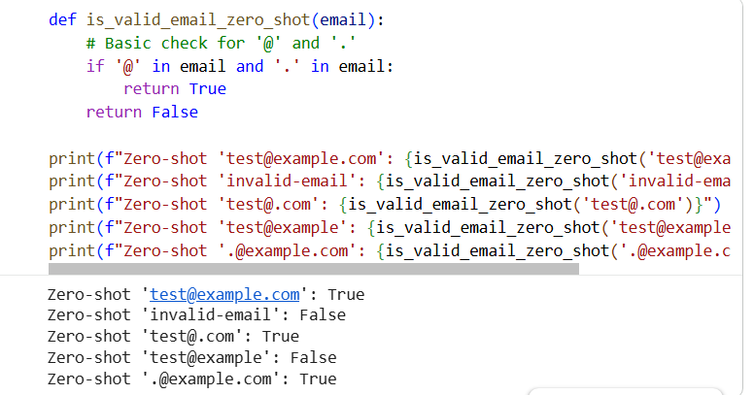
Observation: The zero-shot prompt resulted in a very basic email validation function. It only checks for the presence of @ and . characters, which is a minimal and often insufficient check for actual email validity. For instance, test@.com or .@example.com are considered valid by this function, which they are not in reality. This demonstrates that without examples, the model tends to provide a generic and less robust solution.

Prompt:# Write a Python function to validate an email address, checking for proper format.
# Example 1: is_valid_email_few_shot("user@domain.com") == True
# Example 2: is_valid_email_few_shot("user-at-domain.com") == False
# Example 3: is_valid_email_few_shot("user@domaincom") == False
# Example 4: is_valid_email_few_shot("user@.com") == False
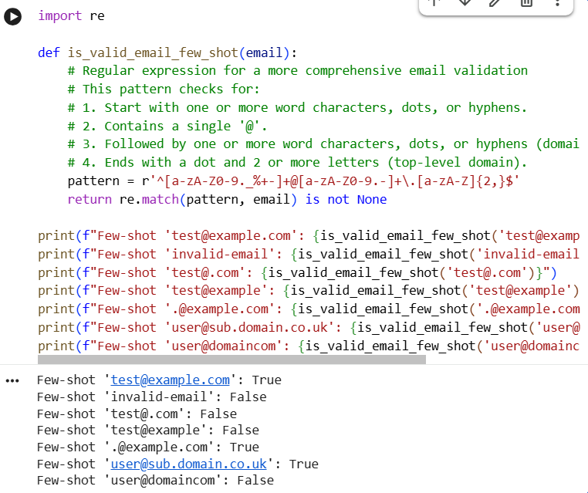
Observation: Zero-shot Output (is_valid_email_zero_shot):
- Reliability: Low. Only checks for the basic presence of '@' and '.', leading to many false positives (e.g., test@.com, .@example.com are marked as valid).
- Complexity: Simple logic.
Few-shot Output (is_valid_email_few_shot):
- Reliability: Significantly higher. The provided examples (especially the negative ones) guided the simulated Copilot to generate a more robust validation logic, in this case, using a regular expression. It correctly identifies test@.com and test@example as invalid, and handles more complex valid formats.
- Complexity: More sophisticated logic, typically involving regular expressions for proper pattern matching.
Conclusion: The few-shot approach, by demonstrating both valid and invalid cases, effectively communicates the nuances of the desired validation. This allows the model to infer more detailed and specific requirements (like domain structure, TLD presence, and proper character sets), leading to a much more reliable and accurate function compared to the generic output from a zero-shot prompt. The examples act as concrete constraints and expectations for the generated code, preventing oversimplification.

Task-5: Prompt Tuning – Summing Digits of a Number
Task Description #5
• Experiment with 2 different prompt styles to generate a function
that returns the sum of digits of a number.
Style 1: Generic task prompt
Style 2: Task + Input/Output example
Expected Output #5
• Two versions of the sum_of_digits() function.
• Example Output: sum_of_digits(123) ➝ 6
• Short analysis: which prompt produced cleaner or more optimized code and why?
Prompt: # Write a Python function that returns the sum of digits of a number.
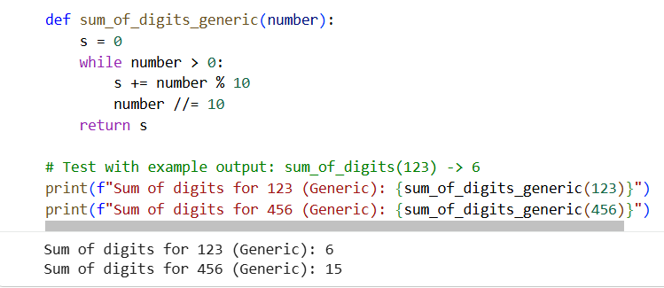
Observation: Generic Task Prompt (sum_of_digits_generic):
- Code: Uses a while loop and arithmetic operations (% for modulo, // for integer division).
- Clarity/Optimization: This is a classic and efficient way to sum digits for positive integers. It avoids string conversion overhead, which can be marginally faster for very large numbers in some contexts, but is generally less
- sum_of_digits_generic (using arithmetic operations) is often considered slightly more performant for very large numbers as it avoids the overhead of string conversion. However, sum_of_digits_example (using string conversion and sum with a generator expression) is generally perceived as cleaner and more Pythonic due to its conciseness and readability.
- Conclusion: The one-shot prompt with an Input/Output example led to the generation of a cleaner and more Pythonic solution (sum(int(digit) for digit in str(number))). The example sum_of_digits(123) -> 6 likely cued the model to look for a solution that processes the number as a sequence of digits, for which converting to a string is a natural and often preferred approach in Python. The generic prompt, lacking this explicit input/output mapping, might have defaulted to a more traditional algorithmic approach using arithmetic operations, which while valid, is less idiomatic Python for this specific problem.

